

Nursing and Midwifery Board of Australia

Registrant data

Reporting period: 1 January 2018 – 31 March 2018

Table of contents
Introduction 3
Principal place of practice 4
1. Registration type 4
2. General Registration 5
3. Non-practising Registration 6
4. Notations 7
Age group 8
5. General registration 8
6. Non-practising registration 9
Gender 10
7. General Registration 10
8. Non-practising Registration 12

Introduction
This report contains registration information about nurses and midwives registered with the Nursing and Midwifery Board of Australia (NMBA).
The functions of the NMBA are defined under the National Law, and include:
- Registering nurses, midwives and students of nursing and midwifery
- Determining national registration requirements
- Developing professional codes, standards, guidelines and position statements to guide the practice of nurses and midwives
- Managing notifications, investigations and panel hearings
- Overseeing the assessment of internationally qualified nurses and midwives who wish to register in Australia
- Approving national accreditation standards and accredited programs of study leading to registration and endorsement
- Delegating to state and territory boards and committees of the NMBA, and AHPRA staff, the power to determine individual applications for registration and notification of a nurse’s or midwife’s health, performance and/or conduct, and a student’s health or criminal history

*Co-regulatory models apply in New South Wales (NSW) and Queensland (QLD). In NSW, notifications are managed separately by the Nursing and Midwifery Council of NSW; the NSW Board of the NMBA only manages registration matters. In QLD, notifications are received by the Office of the Health Ombudsman (OHO), who determines which notifications should be managed by the NMBA.
The NMBA’s functions are supported by the Australian Health Practitioner Regulation Agency (AHPRA). For information about legislation governing the NMBA and AHPRA, see AHPRA's Legislation & Publications at www.ahpra.gov.au/Legislation-and-Publications.aspx
AHPRA has analysed the NMBA’s registration data and produced a number of statistical tables about registrants to share with the professions and community. This report is updated on a quarterly basis.
For more information on nursing and midwifery registration, please see the NMBA’s website: www.nursingmidwiferyboard.gov.au/Registration-and-Endorsement.aspx

Principal place of practice
- Registration type
Registration type by principal place of practice*
Profession | Registration type | Divisions | ACT | NSW | NT | QLD | SA | TAS | VIC | WA | No PPP | Total
Nurse | General | Enrolled Nurse (EN) | 698 | 13,569 | 401 | 13,064 | 7,690 | 1,543 | 20,243 | 5,408 | 111 | 62,727
Nurse | General | Registered Nurse (RN) | 4,925 | 83,112 | 3,407 | 57,375 | 22,345 | 6,835 | 71,972 | 29,562 | 10,083 | 289,616
Nurse | General | EN & RN | 81 | 1,429 | 66 | 1,624 | 829 | 78 | 2,974 | 712 | 28 | 7,821
Nurse | Total General Nurse |  | 5,704 | 98,110 | 3,874 | 72,063 | 30,864 | 8,456 | 95,189 | 35,682 | 10,222 | 360,164
Nurse | Non-practising | Enrolled Nurse (EN) | 20 | 310 | 6 | 176 | 131 | 25 | 237 | 81 | 17 | 1,003
Nurse | Non-practising | Registered Nurse (RN) | 78 | 1,460 | 23 | 601 | 302 | 103 | 656 | 315 | 455 | 3,993
Nurse | Non-practising | EN & RN | 1 | 3 |  | 3 | 5 |  | 9 |  | 5 | 26
Nurse | Total Non-practising Nurse |  | 99 | 1,773 | 29 | 780 | 438 | 128 | 902 | 396 | 477 | 5,022
Total Nurse |  |  | 5,803 | 99,883 | 3,903 | 72,843 | 31,302 | 8,584 | 96,091 | 36,078 | 10,699 | 365,186
Nurse & Midwife | General | EN & Midwife | 1 | 6 | 4 | 25 | 7 |  | 32 | 1 |  | 76
Nurse & Midwife | General | RN & Midwife | 502 | 7,734 | 490 | 5,676 | 1,861 | 624 | 7,460 | 2,826 | 291 | 27,464
Nurse & Midwife | General | EN & RN & Midwife |  | 18 | 2 | 7 | 2 | 2 | 34 | 13 |  | 78
Nurse & Midwife | Total General NMW |  | 503 | 7,758 | 496 | 5,708 | 1,870 | 626 | 7,526 | 2,840 | 291 | 27,618
Nurse & Midwife | Non-practising | EN & Midwife |  |  |  |  |  |  | 1 |  |  | 1
Nurse & Midwife | Non-practising | RN & Midwife | 17 | 284 |  | 88 | 38 | 10 | 103 | 42 | 26 | 608
Nurse & Midwife | Total Non-practising NMW |  | 17 | 284 |  | 88 | 38 | 10 | 104 | 42 | 26 | 609
Total NMW |  |  | 520 | 8,042 | 496 | 5,796 | 1,908 | 636 | 7,630 | 2,882 | 317 | 28,227
Midwife | General |  | 163 | 1,171 | 89 | 1,024 | 624 | 33 | 1,326 | 430 | 191 | 5,051
Midwife | Non-practising |  | 1 | 17 |  | 9 | 8 |  | 17 | 7 | 7 | 66
Total Midwife |  |  | 164 | 1,188 | 89 | 1,033 | 632 | 33 | 1,343 | 437 | 198 | 5,117
Total |  |  | 6,487 | 109,113 | 4,488 | 79,672 | 33,842 | 9,253 | 105,064 | 39,397 | 11,214 | 398,530
* The Nursing and Midwifery Board introduced Provisional Registration for Nurses and Midwives in September 2015. Data about the number of provisional registrants is being captured and will be reported in the near future.

- General Registration
Totals for practitioners with general registration as Nurse and/or Midwife
 | ACT | NSW | NT | QLD | SA | TAS | VIC | WA | No PPP | Total
Enrolled Nurse (EN) | 698 | 13,569 | 401 | 13,064 | 7,690 | 1,543 | 20,243 | 5,408 | 111 | 62,727
Registered Nurse (RN) | 4,925 | 83,112 | 3,407 | 57,375 | 22,345 | 6,835 | 71,972 | 29,562 | 10,083 | 289,616
EN & RN | 81 | 1,429 | 66 | 1,624 | 829 | 78 | 2,974 | 712 | 28 | 7,821
Midwife | 163 | 1,171 | 89 | 1,024 | 624 | 33 | 1,326 | 430 | 191 | 5,051
Nurse (EN & RN) and Midwife* | 503 | 7,758 | 496 | 5,708 | 1,870 | 626 | 7,526 | 2,840 | 291 | 27,618
* Practitioners with a Nurse and Midwife registration may hold registration as an EN and Midwife, RN and Midwife, or EN and RN and Midwife.

Percentage of general registration by principal place of practice

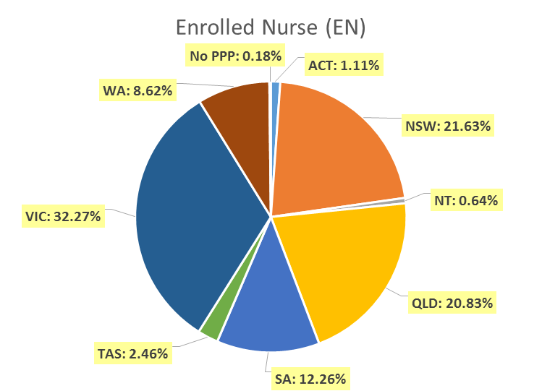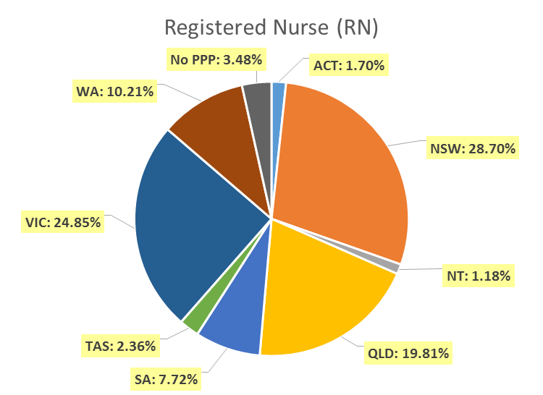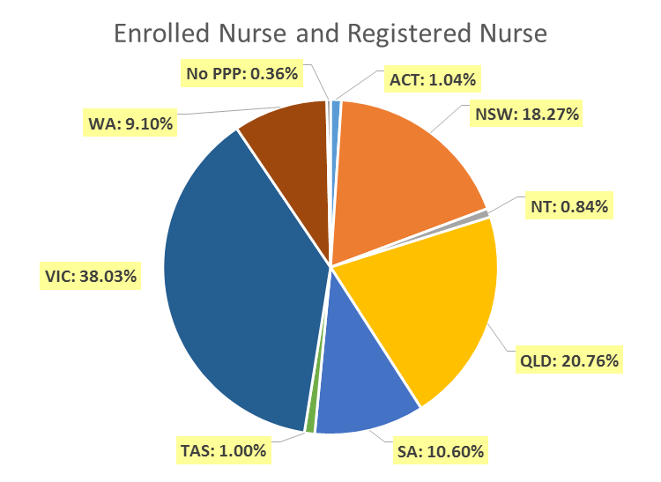

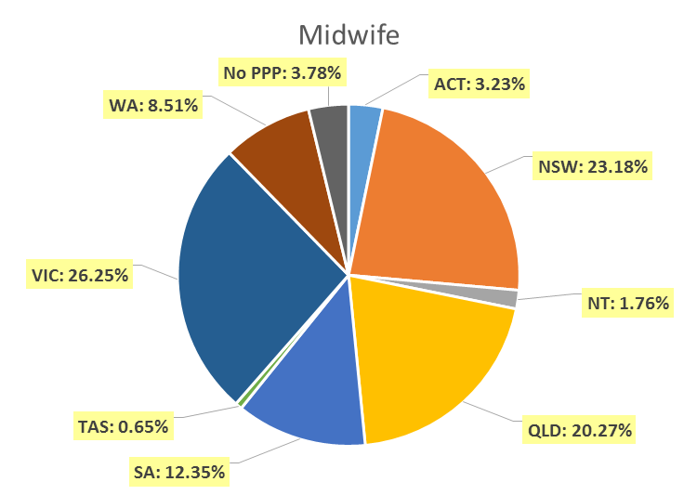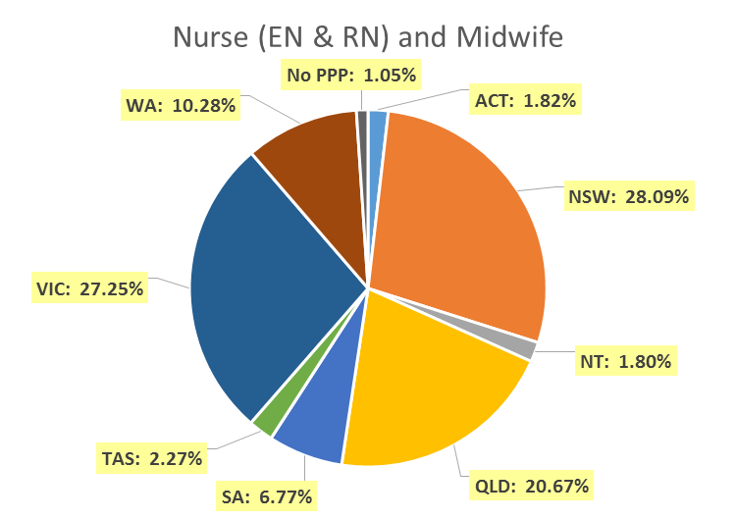

- Non-practising Registration
Totals for practitioners with non-practising registration as Nurse and/or Midwife
Division | ACT | NSW | NT | QLD | SA | TAS | VIC | WA | No PPP | Total
Enrolled Nurse (EN) | 20 | 310 | 6 | 176 | 131 | 25 | 237 | 81 | 17 | 1,003
Registered Nurse (RN) | 78 | 1,460 | 23 | 601 | 302 | 103 | 656 | 315 | 455 | 3,993
EN & RN | 1 | 3 |  | 3 | 5 |  | 9 |  | 5 | 26
Midwife | 1 | 17 |  | 9 | 8 |  | 17 | 7 | 7 | 66
Nurse (EN & RN) and Midwife* | 17 | 284 |  | 88 | 38 | 10 | 104 | 42 | 26 | 609
* Practitioners with a Nurse and Midwife registration may hold registration as an EN and Midwife, RN and Midwife, or EN and RN and Midwife.
Percentage of non-practising registration by principal place of practice

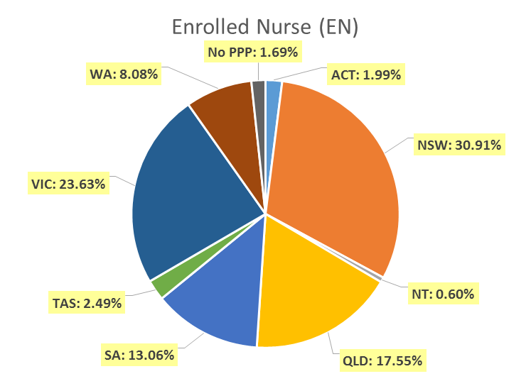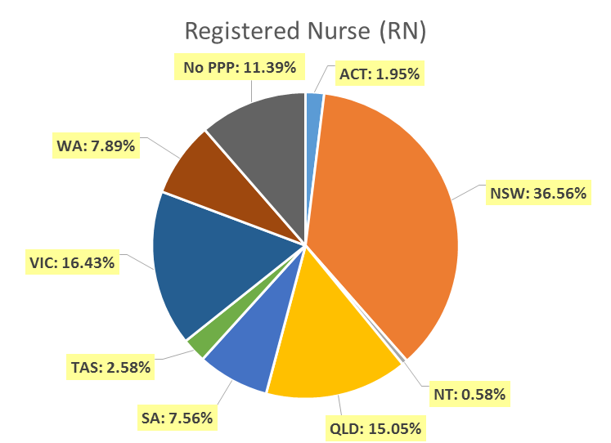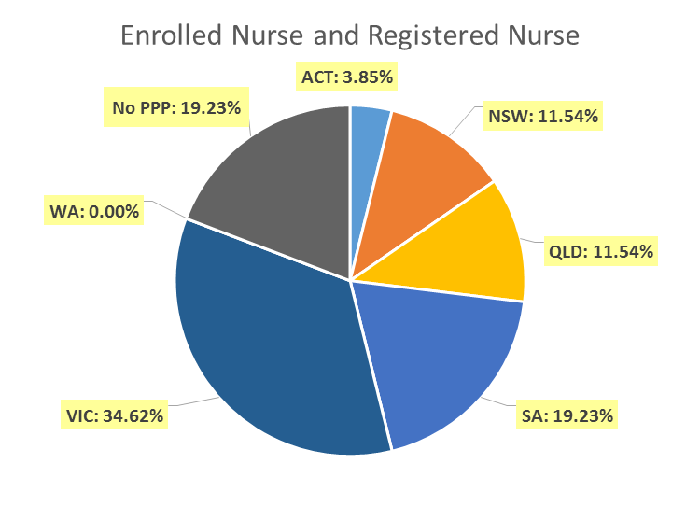

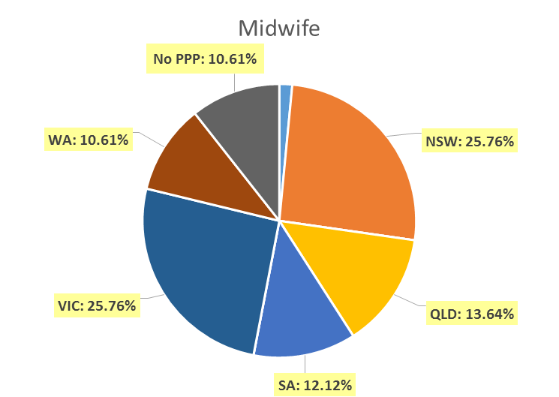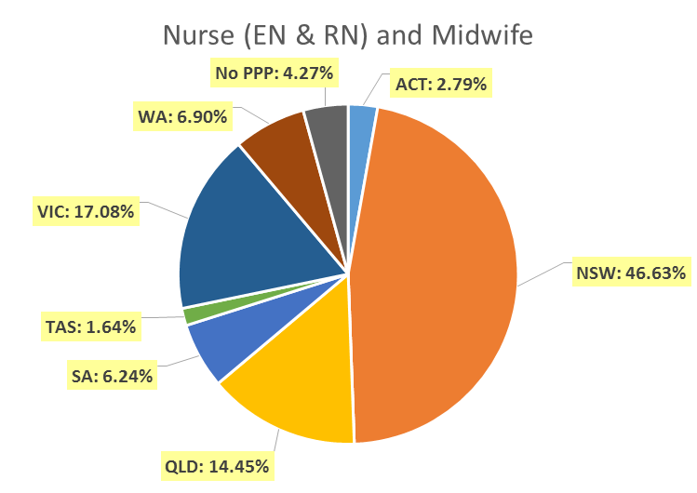
Endorsements by Type
The NMBA endorsements for registered nurses are:
- Nurse Practitioner
- Registered Nurse - scheduled medicines (rural and isolated practice)
The NMBA endorsements for midwives are:
- Midwife – scheduled medicines
- Midwife Practitioner – refer Position-Statement Midwife Practitioners (7 April 2011)
Registered Nurse and Midwife – Endorsements by principal place of practice
Profession | Endorsement | ACT | NSW | NT | QLD | SA | TAS | VIC | WA | No PPP | Total
Nurse | Nurse Practitioner | 43 | 375 | 25 | 440 | 139 | 35 | 339 | 252 | 26 | 1,674
Nurse | Scheduled Medicines - Rural and isolated practice | 6 | 50 | 23 | 841 | 7 | 8 | 180 | 23 | 8 | 1,146
Midwife | Scheduled Medicines* | 3 | 63 | 4 | 148 | 37 | 10 | 74 | 68 |  | 407
Midwife | Midwife Practitioner |  | 1 |  |  |  |  |  |  |  | 1
Total |  | 52 | 489 | 52 | 1,429 | 183 | 53 | 593 | 343 | 34 | 3,228
* The above numbers under ‘Midwife Scheduled Medicines’ reflect those midwives who have met the NMBA Registration standard for endorsement for scheduled medicines for midwives.
- Notations
Registered nurses with a sole qualification in mental health nursing or paediatric nursing or disability nursing - rather than a qualification in general nursing - are identified on the national register with a notation, which states: Solely qualified in the area of Disability Nursing / Mental Health Nursing / Paediatric Nursing.
Registered Nurse notations
Notation | ACT | NSW | NT | QLD | SA | TAS | VIC | WA | No PPP | Total
Disability Nursing |  | 41 | 2 | 11 | 5 |  | 12 | 20 | 18 | 109
Mental health nursing | 8 | 273 | 26 | 180 | 221 | 16 | 279 | 1,052 | 174 | 2,229
Paediatric Nursing | 2 | 141 | 2 | 106 | 16 | 2 | 76 | 152 | 83 | 580
Total | 10 | 455 | 30 | 297 | 242 | 18 | 367 | 1,224 | 275 | 2,918
The NMBA also recognises midwives that meet the requirements of the Eligible Midwife registration standard with a notation on their registration.
The notation states:
Eligible midwife competent to provide pregnancy, labour, birth and post-natal care and qualified to provide the associated services and order diagnostic investigations required for midwifery practice, in accordance with relevant State and Territory legislation.
Midwife notations
Notation | ACT | NSW | NT | QLD | SA | TAS | VIC | WA | No PPP | Total
Eligible Midwife* | 1 | 1 | 1 | 7 | 2 |  | 3 | 3 |  | 18
* The above numbers reflect those midwives with the Eligible midwife notation only. An Eligible midwife, may be qualified to apply for endorsement for scheduled medicines for midwives under section 94 to prescribe Schedule 2, 3, 4 & 8 medicines when they have completed a NMBA-approved program of study and meet the requirements of the NMBA Registration standard for endorsement for scheduled medicines for midwives.
Age group
- General registration
General registration by age group
 | Nurse |  |  | Nurse & Midwife |  |  | Midwife | Total
Age group | EN | RN | EN & RN | EN | RN | EN & RN | Midwife | Total | % age bracket
U - 25 | 5,120 | 15,816 | 583 | 2 | 612 | 4 | 478 | 22,615 | 5.8%
25 - 29 | 5,915 | 35,084 | 1,690 | 14 | 1,733 | 28 | 939 | 45,403 | 11.6%
30 - 34 | 5,767 | 41,891 | 1,556 | 14 | 1,983 | 11 | 833 | 52,055 | 13.3%
35 - 39 | 5,111 | 32,450 | 965 | 13 | 1,869 | 10 | 682 | 41,100 | 10.5%
40 - 44 | 5,192 | 32,379 | 844 | 10 | 2,068 | 7 | 655 | 41,155 | 10.5%
45 - 49 | 7,028 | 34,469 | 809 | 13 | 2,881 | 6 | 553 | 45,759 | 11.6%
50 - 54 | 8,415 | 29,512 | 682 | 7 | 3,960 | 8 | 397 | 42,981 | 10.9%
55 - 59 | 9,956 | 31,386 | 468 | 2 | 5,730 | 2 | 257 | 47,801 | 12.2%
60 - 64 | 7,144 | 23,549 | 170 | 1 | 4,366 | 2 | 168 | 35,400 | 9.0%
65 - 69 | 2,530 | 10,002 | 45 |  | 1,760 |  | 62 | 14,399 | 3.7%
70 - 74 | 486 | 2,546 | 7 |  | 415 |  | 25 | 3,479 | 0.9%
75 - 79 | 52 | 452 | 2 |  | 74 |  | 2 | 582 | 0.1%
80+ | 11 | 80 |  |  | 13 |  |  | 104 | <0.1%
Total | 62,727 | 289,616 | 7,821 | 76 | 27,464 | 78 | 5,051 | 392,833 | 100.0%

General registration by age group
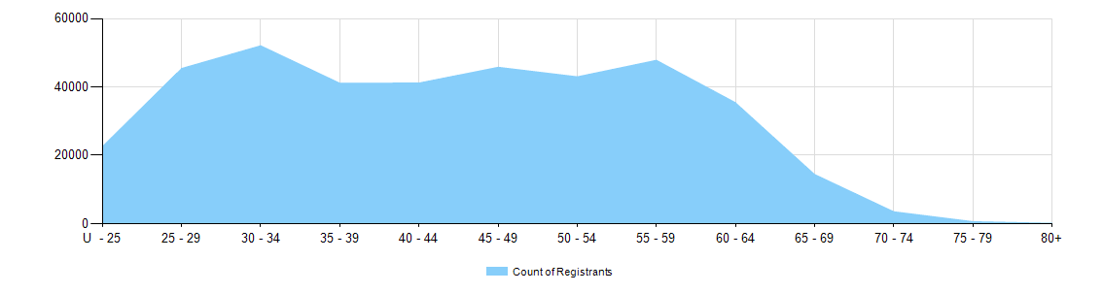

- Non-practising registration
Non-practising registration by age group
 | Nurse |  |  | Nurse & Midwife
Age group | EN | RN | EN & RN | EN | RN | EN & RN | Midwife | Total | % age bracket
U - 25 | 27 | 32 |  |  | 1 |  |  | 60 | 1.1%
25 - 29 | 61 | 244 | 6 |  | 6 |  | 8 | 325 | 5.7%
30 - 34 | 64 | 343 | 1 | 1 | 12 |  | 5 | 426 | 7.5%
35 - 39 | 76 | 388 | 2 |  | 18 |  | 8 | 492 | 8.6%
40 - 44 | 77 | 343 | 3 |  | 25 |  | 9 | 457 | 8.0%
45 - 49 | 121 | 418 | 2 |  | 48 |  | 4 | 593 | 10.4%
50 - 54 | 148 | 368 | 3 |  | 47 |  | 10 | 576 | 10.1%
55 - 59 | 184 | 518 | 4 |  | 100 |  | 9 | 815 | 14.3%
60 - 64 | 159 | 653 | 3 |  | 152 |  | 10 | 977 | 17.1%
65 - 69 | 69 | 427 | 1 |  | 125 |  |  | 622 | 10.9%
70 - 74 | 12 | 180 | 1 |  | 52 |  | 2 | 247 | 4.3%
75 - 79 | 5 | 58 |  |  | 15 |  |  | 78 | 1.4%
80+ |  | 21 |  |  | 7 |  | 1 | 29 | 0.5%
Total | 1,003 | 3,993 | 26 | 1 | 608 | 0 | 66 | 5,697 | 100.0%

Non-practising registration by age group

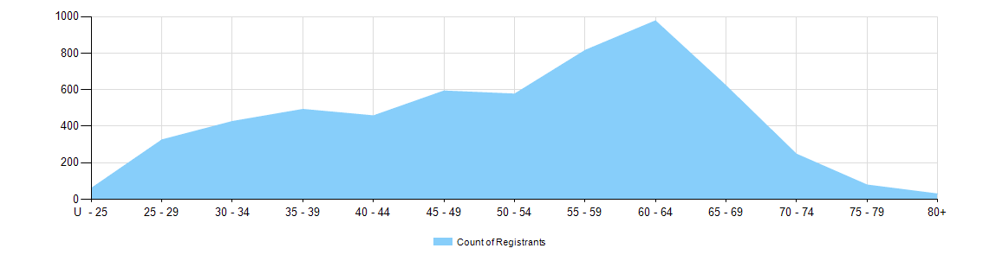

Gender
- General Registration
General registration by gender
Profession | Gender | Divisions |  | ACT | NSW | NT | QLD | SA | TAS | VIC | WA | No PPP | Total
Nurse | Female | Enrolled Nurse (EN) |  | 621 | 12,029 | 332 | 11,719 | 6,970 | 1,404 | 18,310 | 4,993 | 97 | 56,475
Nurse | Female | Registered Nurse (RN) |  | 4,260 | 71,820 | 2,875 | 50,738 | 19,672 | 5,991 | 63,764 | 26,670 | 8,547 | 254,337
Nurse | Female | EN & RN |  | 66 | 1,213 | 56 | 1,418 | 673 | 73 | 2,566 | 648 | 27 | 6,740
Nurse | Total female General Nurse |  |  | 4,947 | 85,062 | 3,263 | 63,875 | 27,315 | 7,468 | 84,640 | 32,311 | 8,671 | 317,552
Nurse | Male | Enrolled Nurse (EN) |  | 77 | 1,540 | 69 | 1,345 | 720 | 139 | 1,933 | 415 | 14 | 6,252
Nurse | Male | Registered Nurse (RN) |  | 665 | 11,291 | 532 | 6,636 | 2,673 | 844 | 8,208 | 2,892 | 1,536 | 35,277
Nurse | Male | EN & RN |  | 15 | 216 | 10 | 206 | 156 | 5 | 408 | 64 | 1 | 1,081
Nurse | Total male General Nurse |  |  | 757 | 13,047 | 611 | 8,187 | 3,549 | 988 | 10,549 | 3,371 | 1,551 | 42,610
Nurse | Intersex or Indeterminate |  | Registered Nurse (RN) |  | 1 |  | 1 |  |  |  |  |  | 2
Total General Nurse |  |  |  | 5,704 | 98,110 | 3,874 | 72,063 | 30,864 | 8,456 | 95,189 | 35,682 | 10,222 | 360,164
Nurse & Midwife* | Female | EN & Midwife |  | 1 | 6 | 3 | 24 | 7 |  | 32 | 1 |  | 74
Nurse & Midwife* | Female | RN & Midwife |  | 494 | 7,559 | 460 | 5,590 | 1,822 | 609 | 7,391 | 2,786 | 285 | 26,996
Nurse & Midwife* | Female | EN & RN & Midwife |  |  | 17 | 2 | 7 | 2 | 2 | 34 | 13 |  | 77
Nurse & Midwife* | Total female General NMW |  |  | 495 | 7,582 | 465 | 5,621 | 1,831 | 611 | 7,457 | 2,800 | 285 | 27,147
Nurse & Midwife* | Male | EN & Midwife |  |  |  | 1 | 1 |  |  |  |  |  | 2
Nurse & Midwife* | Male | RN & Midwife |  | 8 | 175 | 30 | 86 | 39 | 15 | 69 | 40 | 6 | 468
Nurse & Midwife* | Male | EN & RN & Midwife |  |  | 1 |  |  |  |  |  |  |  | 1
Nurse & Midwife* | Total male General NMW |  |  | 8 | 176 | 31 | 87 | 39 | 15 | 69 | 40 | 6 | 471
Total General NMW |  |  |  | 503 | 7,758 | 496 | 5,708 | 1,870 | 626 | 7,526 | 2,840 | 291 | 27,618
Midwife | Female |  |  | 162 | 1,165 | 88 | 1,023 | 622 | 31 | 1,320 | 430 | 191 | 5,032
Midwife | Male |  |  | 1 | 6 | 1 | 1 | 2 | 2 | 6 |  |  | 19
Total General Midwife |  |  |  | 163 | 1,171 | 89 | 1,024 | 624 | 33 | 1,326 | 430 | 191 | 5,051
Total |  |  |  | 6,370 | 107,039 | 4,459 | 78,795 | 33,358 | 9,115 | 104,041 | 38,952 | 10,704 | 392,833
* Practitioners with a Nurse and Midwife registration may hold registration as an EN and Midwife, RN and Midwife, or EN and RN and Midwife.

Total general registration by gender
Gender | ACT | NSW | NT | QLD | SA | TAS | VIC | WA | No PPP | Total
Female | 5,604 | 93,809 | 3,816 | 70,519 | 29,768 | 8,110 | 93,417 | 35,541 | 9,147 | 349,731
Male | 766 | 13,229 | 643 | 8,275 | 3,590 | 1,005 | 10,624 | 3,411 | 1,557 | 43,100
Intersex or Indeterminate |  | 1 |  | 1 |  |  |  |  |  | 2

Total general registration by gender percentages
Gender | ACT | NSW | NT | QLD | SA | TAS | VIC | WA | No PPP | Total
Female | 88.0% | 87.6% | 85.6% | 89.5% | 89.2% | 89.0% | 89.8% | 91.2% | 85.5% | 89.0%
Male | 12.0% | 12.4% | 14.4% | 10.5% | 10.8% | 11.0% | 10.2% | 8.8% | 14.5% | 11.0%
Intersex or Indeterminate |  | <0.1% |  | <0.1% |  |  |  |  |  | <0.1%

- Non-practising Registration
Non-practising registration by gender
Profession | Gender | Divisions |  | ACT | NSW | NT | QLD | SA | TAS | VIC | WA | No PPP | Total
Nurse | Female | Enrolled Nurse (EN) |  | 19 | 281 | 5 | 167 | 125 | 23 | 224 | 77 | 16 | 937
Nurse | Female | Registered Nurse (RN) |  | 69 | 1,326 | 19 | 549 | 260 | 97 | 596 | 299 | 413 | 3,628
Nurse | Female | EN & RN |  | 1 | 3 |  | 3 | 4 |  | 8 |  | 4 | 23
Nurse | Total Female  Non-practising Nurse |  |  | 89 | 1,610 | 24 | 719 | 389 | 120 | 828 | 376 | 433 | 4,588
Nurse | Male | Enrolled Nurse (EN) |  | 1 | 29 | 1 | 9 | 6 | 2 | 13 | 4 | 1 | 66
Nurse | Male | Registered Nurse (RN) |  | 9 | 134 | 4 | 52 | 42 | 6 | 60 | 16 | 42 | 365
Nurse | Male | EN & RN |  |  |  |  |  | 1 |  | 1 |  | 1 | 3
Nurse | Total Male  Non-practising Nurse |  |  | 10 | 163 | 5 | 61 | 49 | 8 | 74 | 20 | 44 | 434
Total Non-practising Nurse |  |  |  | 99 | 1,773 | 29 | 780 | 438 | 128 | 902 | 396 | 477 | 5,022
Nurse & Midwife | Female | EN & Midwife |  |  |  |  |  |  |  | 1 |  |  | 1
Nurse & Midwife | Female | RN & Midwife |  | 16 | 276 |  | 86 | 38 | 10 | 103 | 42 | 26 | 597
Nurse & Midwife | Total Female  Non-practising NMW |  |  | 16 | 276 |  | 86 | 38 | 10 | 104 | 42 | 26 | 598
Nurse & Midwife | Male |  | RN & Midwife | 1 | 8 |  | 2 |  |  |  |  |  | 11
Nurse & Midwife | Total Male  Non-practising NMW |  |  | 1 | 8 |  | 2 |  |  |  |  |  | 11
Total Non-practising NMW |  |  |  | 17 | 284 |  | 88 | 38 | 10 | 104 | 42 | 26 | 609
Midwife | Female |  |  | 1 | 17 |  | 9 | 8 |  | 17 | 7 | 7 | 66
Midwife | Male
Total Non-practising Midwife |  |  |  | 1 | 17 |  | 9 | 8 |  | 17 | 7 | 7 | 66
Total |  |  |  | 117 | 2,074 | 29 | 877 | 484 | 138 | 1,023 | 445 | 510 | 5,697

Total non-practising registration by gender
Gender | ACT | NSW | NT | QLD | SA | TAS | VIC | WA | No PPP | Total
Female | 106 | 1,903 | 24 | 814 | 435 | 130 | 949 | 425 | 466 | 5,252
Male | 11 | 171 | 5 | 63 | 49 | 8 | 74 | 20 | 44 | 445

Total non-practising registration by gender percentages
Gender | ACT | NSW | NT | QLD | SA | TAS | VIC | WA | No PPP | Total
Female | 90.6% | 91.8% | 82.8% | 92.8% | 89.9% | 94.2% | 92.8% | 95.5% | 91.4% | 92.2%
Male | 9.4% | 8.2% | 17.2% | 7.2% | 10.1% | 5.8% | 7.2% | 4.5% | 8.6% | 7.8%

Note that the data for dual registration in the tables and diagrams includes where a nurse or a midwife may be non-practising in one category, for example enrolled nurse (non-practising) & registered nurse (practising) or nurse (non-practising) & midwife (practising).

