Communiqué
Meeting of the Nursing and Midwifery Board of Australia
23 May 2013 in Melbourne

The Nursing and Midwifery Board of Australia (the National Board or NMBA) is the national regulator for the nursing and midwifery professions in Australia. It is established under the Health Practitioner Regulation National Law, as in force in each state and territory (the National Law).
The National Board meets monthly and considers a range of matters, the most important of which are published in this Communiqué.
In order to facilitate engagement with local stakeholders across states and territories, the National Board now holds its monthly meeting in a different state and territory every two to three months.
This helps the National Board to gain a better understanding of the jurisdictional matters relating to the regulation of nurses, midwives and students, and supports information sharing with the local branches or chapters of the Australian College of Nursing, Australian College of Midwives and the Australian Nursing Federation; the Chief Nurse and Midwifery Officer and education providers, among other stakeholders, on the National Board’s strategic priorities, projects and regulatory functions.
ANMAC as the accreditation authority for next five years
The National Board has appointed the Australian Nursing and Midwifery Accreditation Council (ANMAC) as the accreditation authority for nursing and midwifery for a period of five years until 30 June 2018.
As the independent accrediting authority for nursing and midwifery under the National Scheme, ANMAC sets the accreditation standards and uses these standards to accredit programs of study that lead to:
- registration as a nurse or midwife, and
- endorsements as a nurse practitioner, eligible midwife and prescribing medicines.
ANMAC’s accreditation standards and the accredited programs of study that lead to registration as a nurse or midwife require National Board approval before implementation.
Read more information on ANMAC's accreditation functions on the ANMAC website.
ANMAC’s appointment was the result of a comprehensive National Board review of the existing accreditation arrangements for nursing and midwifery. The review involved wide-ranging consultation with the National Board’s stakeholders.
This review was a legislative requirement under the National Law and all 10 National Boards that joined the National Scheme on 1 July 2010 (18 October 2010 in Western Australia) were required to undertake a review of their accreditation arrangements.
The National Board has published the submissions received in response to the review under past consultations on its website.
New fact sheet on advance practice nursing
The National Board has approved for publication a new fact sheet on advanced practice nursing..
The purpose of the fact sheet is to give advice to:
- applicants to the National Board for nurse practitioner endorsement
- education providers offering approved programs of study for nurse practitioners, and
- assessors of nurse practitioner applications for endorsement, and
- employers.
The fact sheet on advance practice nursing addresses practice domains in the Australian context, and how the role of the advanced practice nurse relates to the nurse practitioner and registered nurse.
Registered nurses working at the advanced practice level are educationally prepared at postgraduate level and may work in a specialised or generalist capacity
Read this Fact sheet on advanced practice nursing under FAQ and fact sheets on the National Board website.
National Board signs MoU with Nursing Council of New Zealand
A recent visit by the Nursing Council of New Zealand to Melbourne in May 2013 saw the signing of a memorandum of understanding (MoU) between the National Board and the Nursing Council of New Zealand.
The MoU formalises a close collaborative relationship between the two entities in the spirit of the Trans Tasman Mutual Recognition Agreement, a non-treaty arrangement between the Australian (Commonwealth), state and territory governments of Australia and the Government of New Zealand.
Areas of collaboration between the two entities will include:
- developing standards for regulating nurses
- exchanging professional knowledge toward developing these standards
- recognising nurses mutually, and
- enabling flexible movement of nurses between Australia and New Zealand.
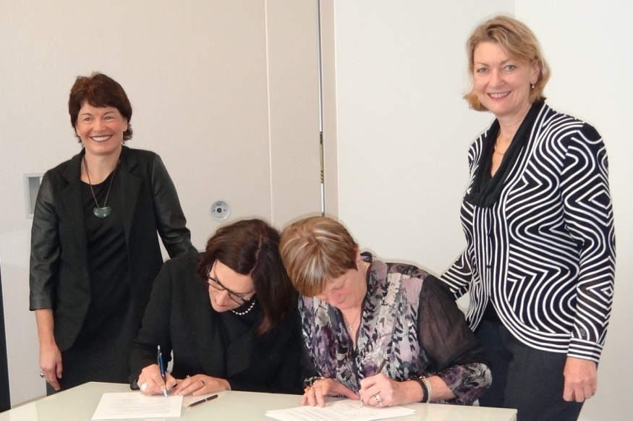
MoU signing: L-R: Dr Deborah Rowe (newly appointed Chair of NCNZ), Carolyn Reed (CEO/Registrar NCNZ), Alyson Smith (Executive Officer Nursing and Midwifery, AHPRA) and Anne Copeland (Chair National Board)
Approved programs of study leading to registration and endorsement
The National Board approved for five years the following programs of study as providing a qualification for the purposes of registration or endorsement:

- San College of Education, Registered Nurse Re-Entry Program Wahroonga, NSW
- Tropical North Queensland Institute of TAFE, Diploma of Nursing Cairns, / Thursday Island, Torres Strait / Mt Isa, Queensland.

The National Board approved for five years with conditions the following programs of study:
- Aboriginal Health College, Diploma of Nursing, Little Bay, NSW.

The National Board approved removal of specific conditions from the following programs of study:
- The Australasian Lawrence Aged Care College Diploma of Nursing.

The National Board approved the following to be moved into ‘inactive’ in the list of approved programs of study:
- Tropical North Queensland Institute of TAFE, Diploma of Nursing, expiry date 1 March 2013

The National Board approved the following change in education provider name:
- Flexible Advanced Creative Training Solutions to Healthcare Training Australia.

The National Board approved the following program prolongations:
- Metropolitan South Institute of TAFE, Diploma of Nursing until 1 August 2013.

The National Board approved the following program changes in unit codes, nominal hours or mode of delivery from the national training package HLT51607 to HLT51612:
- Partners in Training
- Box Hill Institute (of TAFE)
- Australasian Lawrence Aged Care College.

For more detailed information please go to the approved program of study lists on the National Board website.

Ms Anne Copeland
Chair, Nursing and Midwifery Board of Australia
7 June 2013

For more information
- Keep up to date with regular news and updates on the National Board website www.nursingmidwiferyboard.gov.au
- Visit www.nursingmidwiferyboard.gov.au under Contact Us to lodge an online enquiry form
- For registration enquiries: 1300 419 495 (within Australia) +61 3 8708 9001 (overseas callers)
- For media enquiries: (03) 8708 9200

